

Semester Two Examination, 2024

Question/Answer booklet

MATHEMATICS METHODS
UNIT 3

Section Two:

Calculator-assumed

Your Name:
Your Teacher’s Name:

Time allowed for this section
Reading time before commencing work: ten minutes
Working time: one hundred minutes

Materials required/recommended for this section
To be provided by the supervisor
This Question/Answer booklet
Formula sheet (retained from Section One)

To be provided by the candidate
Standard items: pens (blue/black preferred), pencils (including coloured), sharpener, correction fluid/tape, eraser, ruler, highlighters

Special items: drawing instruments, templates, notes on two unfolded sheets of A4 paper, and up to three calculators approved for use in this examination

Important note to candidates
No other items may be taken into the examination room. It is your responsibility to ensure that you do not have any unauthorised material. If you have any unauthorised material with you, hand it to the supervisor before reading any further.

Question | Marks | Max | Question | Marks | Max
9 |  | 7 | 15 |  | 14
10 |  | 7 | 16 |  | 11
11 |  | 9 | 17 |  | 15
12 |  | 3 | 18 |  | 8
13 |  | 6 | 19 |  | 7
14 |  | 15

Structure of this paper

Section | Number of questions available | Number of questions to be answered | Working time (minutes) | Marks available | Percentage of examination
Section One:  Calculator-free | 8 | 8 | 50 | 50 | 32.9
Section Two:  Calculator-assumed | 11 | 11 | 100 | 102 | 67.1
 |  |  |  | Total | 100

Instructions to candidates

- The rules for the conduct of the Western Australian Certificate of Education ATAR course examinations are detailed in the Year 12 Information Handbook 2019. Sitting this examination implies that you agree to abide by these rules.

- Write your answers in this Question/Answer booklet.

- You must be careful to confine your answers to the specific questions asked and to follow any instructions that are specific to a particular question.

- Additional pages for the use of planning your answer to a question or continuing your answer to a question have been provided at the end of this Question/Answer booklet. If you use the space to continue an answer, indicate in the original answer space where the answer is continued, i.e. give the page number.

- Show all your working clearly. Your working should be in sufficient detail to allow your answers to be checked readily and for marks to be awarded for reasoning. Incorrect answers given without supporting reasoning cannot be allocated any marks. For any question or part question worth more than two marks, valid working or justification is required to receive full marks. If you repeat any question, ensure that you cancel the answer you do not wish to have marked.

- It is recommended that you do not use pencil, except in diagrams.

- The Formula sheet is not to be handed in with your Question/Answer booklet.

Section Two: Calculator-assumed (102 Marks)

This section has eleven questions. Answer all questions. Write your answers in the spaces provided.

Spare pages are included at the end of this booklet. They can be used for planning your responses and/or as additional space if required to continue an answer.
● Planning: If you use the spare pages for planning, indicate this clearly at the top of the page.
● Continuing an answer: If you need to use the space to continue an answer, indicate in the original answer space where the answer is continued, i.e. give the page number. Fill in the number of the question that you are continuing to answer at the top of the page.

Working time: 100 minutes.

Question 9 (7 marks)
The level of methane $m$ parts per billion in the atmosphere recorded by a monitoring station can be modelled by the equation $m=1734e^{0.0036t}$, where $t$ years is the time since the station opened at the start of $1997$.
- Determine the initial level of methane in the atmosphere when the station opened at the start of $1997.$ (1 mark)

Solution
$$m\left(0\right)=1734e^{0.0036\left(0\right)}=1734$$

Initial level is $1734$ parts per billion.

Specific behaviours
calculates final level
ü calculates increase

(b) Determine the rate of growth in the level of methane in the atmosphere at the start of the year $2024$. (2 marks)

Solution
$$\frac{dm}{dt}=0.0036m \\ =0.0036\left(1911\right) \\ =6.88$$

The rate of growth is $6.88$ parts per billion per year.

Specific behaviours
indicates use of appropriate method
ü correct rate of growth

(c) A newspaper recently quoted a claim by a scientist that the amount of nitrous oxide in the atmosphere had increased by $40\%$ in the last $40$ years to its current level of $330$ parts per billion. Use this claim and an exponential growth model of the form $n=ae^{bt}$ to predict its level in $5$ years' time. (3 marks)
Solution
$$e^{b(40)}=1.4 \\ b=0.008412$$

$$n=330e^{0.008412\left(5\right)}=344.2$$

The level will be $344.2$ parts per billion.

Specific behaviours
ü forms equation to solve for $b$
ü correct value of $b$
ü correct level
(No FT was awarded if incorrect t used)

Question 10 (7 marks)
A small body moves in a straight line so that at time $t$ seconds, $t≥0$, it has acceleration given by $a\left(t\right)=4.2-0.6t$ metres per second.

When $t=1$, the velocity of the body is $-3.3$ metres per second.

(a) Determine an expression for the velocity $v$ of the body at time $t$. (2 marks)
Solution
$$v=\int{4.2-0.6t}dt \\ =4.2t-0.3t^{2}+c$$
$$v\left(1\right)=-3.3⇒c=-3.3+0.3{\left(1\right)}^{2}-4.2\left(1\right)⇒c=-7.2$$

$$v=4.2t-0.3t^{2}-7.2$$

Specific behaviours
ü indicates velocity is integral of acceleration
ü correct expression for velocity

The velocity of the body is a maximum when $t=t_{1}$.

(b) Determine $t_{1}$ and the velocity of the body at this time. (2 marks)
Solution
$$a\left(t\right)=0⇒4.2-0.6t=0⇒t=7$$
$$v\left(7\right)=4.2\left(7\right)-0.3{\left(7\right)}^{2}-7.2 \\ =7.5 \text{m/s}$$

Specific behaviours
ü correct time
ü correct minimum velocity

(c) Determine the distance travelled by the body between $t=0$ and $t=t_{1}$. (3 marks)
Solution
$$v=0⇒t=2, 12 \text{s}$$
Note that $v≤0$ for $0≤t≤2$ and $v>0$ for $2<t≤7$.

$d=-\int_{0}^{2}{v\left(t\right)}dt+\int_{2}^{7}{v\left(t\right)}dt$ $$=-\left(-6.8\right)+25 \\ =31.8 \text{m}$$
OR
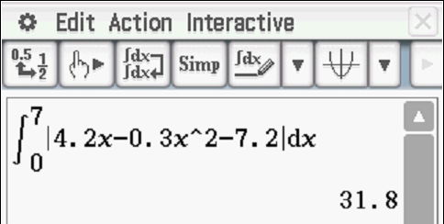

Specific behaviours
ü indicates $v$ changes sign in interval (OR use of $|v|$)
ü shows correct integrals for distance inc speed as below with limits
ü correct distance travelled with units

Question 11 (9 marks)
At the beginning of 2024, a company developed a model to predict their profit.
The company’s profit at that time was $5 million. The model developed was
$$P\left(t\right)= \frac{50 \ln\left(2t+a\right)}{t+10};$$
$$where P\left(t\right) is profit in millions of dollars after t years$$
$$and t is measured in years, 0≤t≤15$$
- Show that $a=e$. (2 marks)
Solution
$$Since P\left(0\right)=5, we require \ln{a}=1,$$
$$⇒a=e.$$

Specific behaviours
ü recognises $P\left(0\right)=5$
ü states $a=e$

- Determine the total profit made by company after 15 years? (1 mark)
Solution
$$P\left(15\right)= \frac{50 \ln\left(2\left(15\right)+a\right)}{15+10}$$
$$=6.976 (3 d.p.)$$
Profit will be approximately $ 6 976 000.
Specific behaviours
ü states the profit with units (ACCEPT ROUNDED)

- Determine the year in which the company reaches its maximum profit and calculate the value of this maximum profit. (2 marks)
Solution
$$Maximum profit is approximately \$8 487 000$$
$This occurs when t=4.532, so during 2028.$
Specific behaviours
ü states maximum profit (no need for units)
ü states it occurs during 2028

- According to the model, during which year will the company’s profit fall below its value at the beginning of 2024? (1 mark)
Solution
$$5= \frac{50 \ln\left(2t+a\right)}{t+10}$$
$$t=0 or 32.0068$$
The model predicts during 2056.
Specific behaviours
ü determine when the profit falls below the 2024 value

- On the axes below, sketch the graph of $P(t)$. (3 marks)
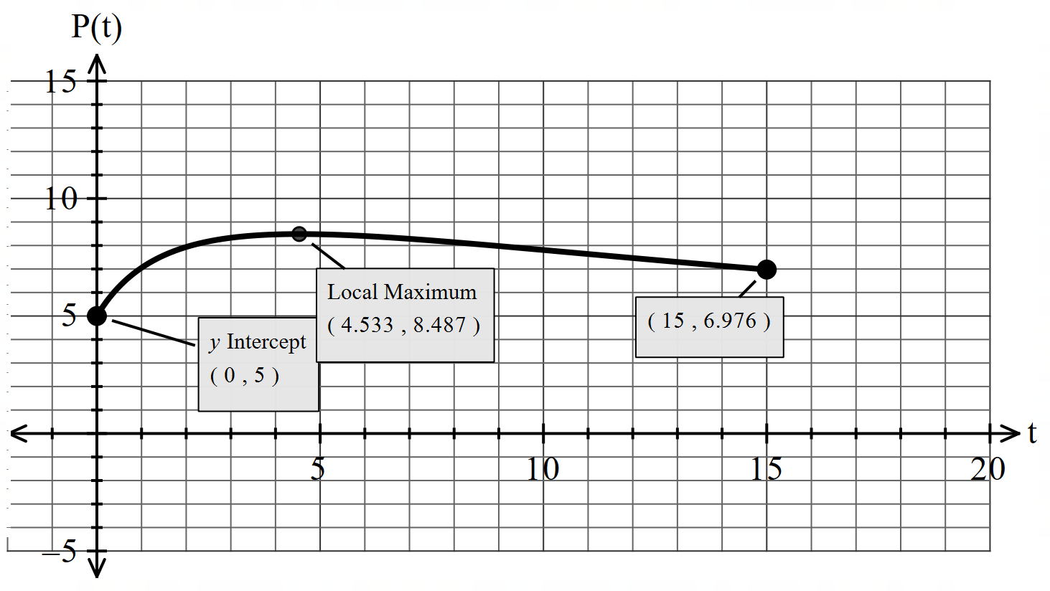

Solution
See graph above
Specific behaviours
ü graph covers at least correct domain and correct shape
ü $P\left(0\right)$correct
ü maximum between 8 and 9

Question 12 (3 marks)
The relationship between $u$ and $w$ is shown on the graph below.
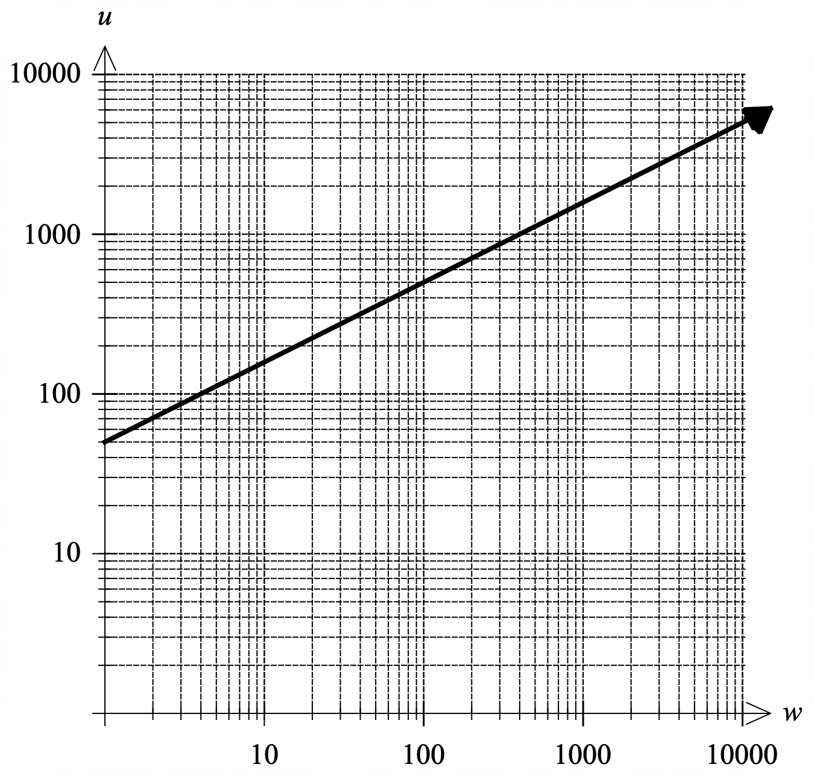
The relationship shown on the graph is given by
$$\log_{10}{(u)}=0.5\log_{10}{(w)}+1.7$$
(a) Explain how the above graph shows that ${10}^{1.7}≈50$. (1 mark)
Solution
$$1.7 is the vertical intercept of the line.$$
$$The line passes through 50 on the$$
$vertical axis, hence {10}^{1.7}≈50$.
Specific behaviours
ü Recognises connection between vertical intercept, and log scale
(Accept: using w = 1 and substituting into the equation to rearrange, and show that 10^{1.7}$≈$ 50

- Hence determine the relationship in the form $u=aw^{b}$, where $a$ and $b$ are constants. (2 marks)
Solution
$$a=50≈{10}^{1.7}$$
$$b=0.5$$
$$u=50w^{0.5}$$
Specific behaviours
- Determines $b$.
- Determines $a$ and states relationship.(accept power expression)

Question 13 (6 marks)
The graph of the cubic function $f\left(x\right)=ax^{3}+bx^{2}+cx+d$ is shown below.
A turning point is located at $(2,0)$ and the shaded region shown on the graph has an area of $16 {units}^{2}.$
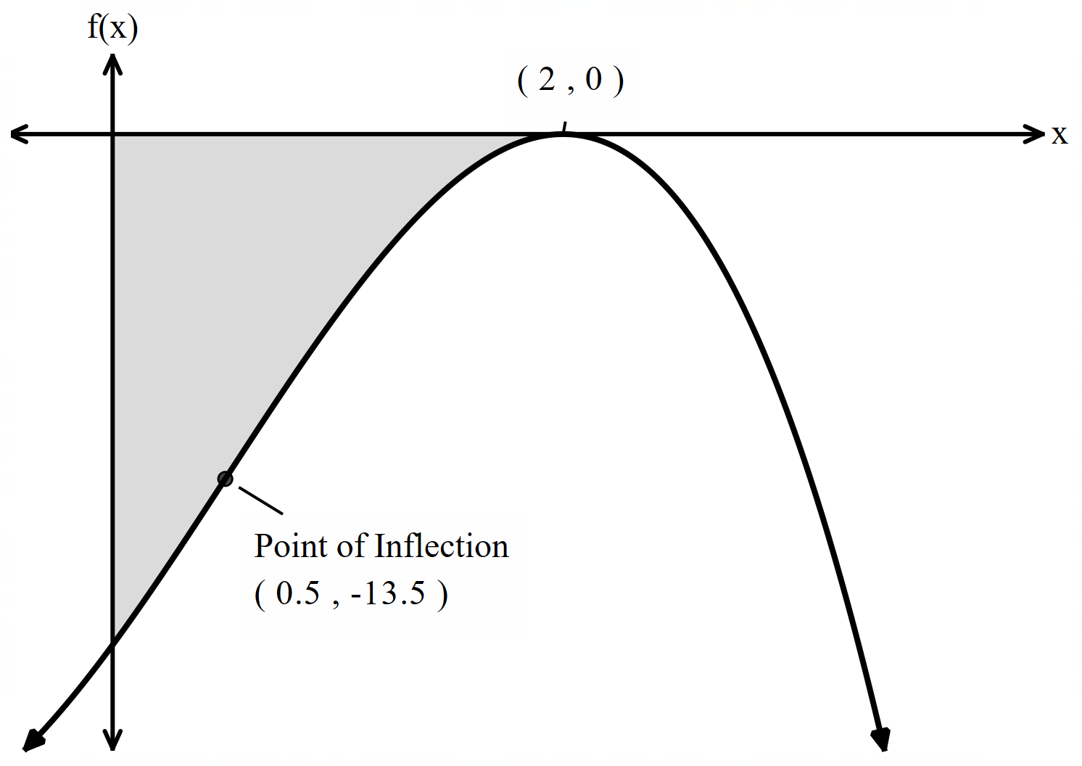

Use the above information to determine the values of $a, b, c and d.$
Solution
Firstly, note that
$$f^{'}\left(x\right)=3ax^{2}+2bx+c$$
and
$$f^{''}\left(x\right)=6ax+2b$$
Given that there is an inflection point at $x=\frac{1}{2}$ , it follows that $f^{''}\left(\frac{1}{2}\right)=0.$Hence,
$$3a+2b=0 ⟹b=-\frac{-3a}{2}$$
Given that there is a turning point at $x=2$ , it follows that $f^{'}\left(2\right)=0.$Hence,
$$12a+4b+c=0⟹c=-6a$$
Given that there is an x-intercept at $x=2$ , it follows that $f\left(2\right)=0.$Hence,
$$8a+4b+2c+d=0⟹d=10a$$
Finally, given that the area of the shaded region is $16$ , it follows that $\int_{0}^{2}{f\left(x\right)dx=-16.}$
$$a\int_{0}^{2}{{(x}^{3}-\frac{3}{2}}x^{2}-6x+10)dx= -16$$
$$a{\left[\frac{x^{4}}{4}-\frac{3x^{3}}{6}-\frac{{6x}^{2}}{2}+10x\right]}_{0}^{2}=-16$$
$$8a=-16⟹a=-2$$

Hence, $a=-2, b=3, c=12, d=-20$
Or
Solving 4 equations using classpad
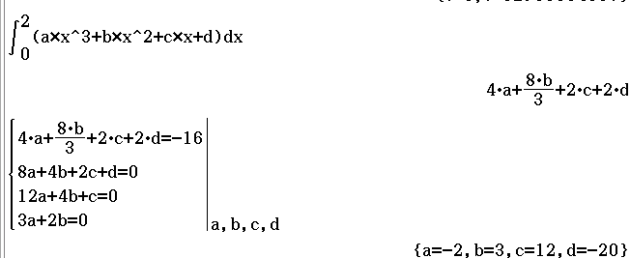
Specific behaviours
ü recognises $f^{''}\left(\frac{1}{2}\right)=0$ and hence that $b=-\frac{-3a}{2}$
ü recognises $f^{'}\left(2\right)=0$ and hence that $c=-6a$
ü recognises $f\left(2\right)=0$ and hence that $d=10a$
ü recognises $\int_{0}^{2}{f\left(x\right)dx=-16}$
ü evaluates definite integral to determine that $a=-2$
ü solves for the values of $b, c and d.$

Question 14 (15 marks)
Faultings is a hardware store that sells discounted hardware.

In the electrical section they have a large box containing many light globes. The box has a sign with the text ‘Super Sale! 40% of these light globes are faulty’.

(a) A customer picks a light globe at random and records whether it is faulty or not. Explain why this is a Bernoulli experiment. (2 marks)

Solution
There is only one trial/sample. There are two possible outcomes
(faulty or not faulty).
Specific behaviours
- States light globe is one sample size
- Indicates there is success or failure.

- Determine the mean and standard deviation for the Bernoulli experiment in part (a). (2 marks)

Solution
$$mean=0.4$$
$$standard deviation=0.4899$$
Specific behaviours
- Determines mean.
- Determines standard deviation.
(Accept either 0.4 or 0.6 for the mean, as the random variable being used is not clearly defined)

A customer needs six working light globes. Based on the sign they buy $10$ light globes.

(c) Assuming the sign is correct,

(i) State the distribution that models the number of working globes. (2 marks)

Solution
$$Let X be the number of working globes$$
$$X\sim Bin\left(10, 0.6\right)$$
Specific behaviours
- Recognises distribution is binomial.
- States parameters for distribution.

(ii) Determine the mean and variance for the distribution in part (c)(i). (2 marks)

Solution
$$E\left(X\right)=6$$
$$Var\left(X\right)=2.4$$
Specific behaviours
- Determines mean.
- Determines variance.

(iii) Assuming the sign is correct, determine the probability that out of the $10$ globes
bought, at least six are working. (1 mark)

Solution
$$\operatorname{Pr}\left(X≥6\right)=0.6331$$
Specific behaviours
- Determines probability.
Question 14 (continued)

A second customer needs eight working light globes for a light fitting in their stairwell.

(d) This customer buys $12$ light globes, and tests them one-by-one. They will stop when they have exactly eight working globes.
Assuming 40% of the globes are faulty, determine the probability they will need to test all $12$ globes. (3 marks)
Solution
$$Out of the first 11 globes, 7 are working$$
$$Let Y be the number of working globes$$
$$Y\sim Bin(11, 0.6)$$
$$\operatorname{Pr}\left(Y=7\right)=0.236490$$

$$Pr\left(need to test all 12\right)$$
$$=0.236490×0.6=0.1419$$
Specific behaviours
- Indicates 7 of the first 11 globes need to be working.
- Determines probability of 7 from 11 globes working.
- Multiplies by 0.6 and determines answer.

Another customer believes only 30% of the globes are working. If there is at least $k$ working globes then Faultings is right, and if the number of working globes is less than $k$ then the customer is right.

(e) The customer takes a sample of $50$ bulbs. Using $k=20$, determine the probability

(i) Faultings is correct in saying 40% of the globes are faulty. (1 mark)
Solution
$$Y_{Faultings}\sim Bin\left(50, 0.6\right)$$
$$\operatorname{Pr}\left(Y_{Faultings}≥20\right)=0.9986$$
Specific behaviours
- Determines probability.

(ii) the customer is correct in saying 30% of the globes are working. (2 marks)
Solution
$$Y_{Customer}\sim Bin\left(50, 0.3\right)$$
$$\operatorname{Pr}\left(Y_{Customer}<20\right)=0.9152$$
Specific behaviours
- Indicates change in distribution and probability statement.
- Determines probability.

Question 15 (14 marks)
Let the random variable $X$ be the capacity of an AAA rechargeable battery when new. It is known that $X$ is normally distributed with a mean of $725$ mA h and a standard deviation of $14.5$ mA h.

(a) Determine the probability that a randomly selected new AAA battery

(i) has a capacity not exceeding $733$ mA h. (1 mark)
Solution
$$P\left(X<733\right)=0.7094$$

Specific behaviours
ü correct probability

(ii) has a capacity of at least $720$ mA h given that it has a capacity not exceeding
$733$ mA h. (2 marks)
Solution
$$P\left(720<X<733\right)=0.3443$$

$$P\left(720<X<733 | X<733\right)=\frac{0.3443}{0.7094}=0.4853$$

Specific behaviours
ü correct probability between bounds
ü correct conditional probability

(b) Determine the capacity exceeded by $12\%$ of new AAA batteries. (1 mark)
Solution
$$P\left(X>c\right)=0.12⇒c=742.04$$

$12\%$ of new batteries exceed $742$ mA h.

Specific behaviours
ü correct capacity

Let the random variable $Y$ be the capacity of an AA rechargeable battery when new. $Y$ is also normally distributed but with a mean of $1928$ mA h and a standard deviation of $σ$.

(c) Use the fact that $19.8\%$ of AA rechargeable batteries have a capacity of greater than
$1960$ mA h to show that $σ=37.7$ mA h. (2 marks)
Solution
$$P\left(Z>z\right)=0.198⇒z=0.8488$$

$$\frac{1960-1928}{σ}=z \\ σ=\frac{32}{0.8488} \\ =37.7$$

Specific behaviours
ü correct standard score for right tail of $19.8\%$
ü shows use of standard score formula to obtain $σ$

The random variables $X$ and $Y$ are related by the equation $Y=aX+b$.

(d) Determine the value of the constant $a$ and the value of the constant $b$. (3 marks)
Solution
Standard deviation of $Y$ is $a$ times standard deviation of $X$:

$$37.7=a×14.5⇒a=2.6$$

$$\overline{Y}=a\overline{X}+b \\ b=1928-2.6×725=43$$

$$a=2.6, b=43$$

Specific behaviours
ü indicates correct relationship between standard deviations
ü correct value of $a$
ü calculates value of $b$
Note: do not penalise if negative values also given

Let the random variable $T$ be the time taken in minutes for an AAA battery to fully recharge when completely drained. The probability density function for $T$ is

$$f\left(t\right)=\left\{ \begin{matrix}\frac{3\sqrt{t}}{254} & 36≤t≤49 \\ \overset{ }{0} & \text{otherwise.}\end{matrix}\right.$$

(e) Determine the probability that an AAA battery recharges in exactly $40$ minutes. (1 mark)
Solution
$$P\left(T=40\right)=0$$

Specific behaviours
ü correct probability

(f) Determine $E(T)$. (2 marks)
Solution
$$E\left(T\right)=\int_{36}^{49}{t×f(t)}dt \\ =42.67 \text{minutes}$$

Specific behaviours
ü shows correct definite integral
ü correct $E(T)$

(g) Determine $\operatorname{Var}\left(T\right)$. (2 marks)
Solution
$$\operatorname{Var}\left(T\right)=\int_{36}^{49}{{\left(t-42.67\right)}^{2}×f\left(t\right)}dt \\ =14.04 {\text{minutes}}^{2}$$

Specific behaviours
ü shows correct definite integral
ü correct $\operatorname{Var}\left(T\right)$

Question 16 (11 marks)

During early 2024 a survey was conducted by a university on the ‘2 Fruit & 5 Veg’ campaign. Participants in the survey were asked if they ate at least 1 piece of fruit and at least 4 vegetables each day.
From the $227$ participants, $134$ said they ate at least 1 piece of fruit and at least 4 vegetables each day.

- What feature of this sample indicates that a normal distribution can be used to model the sample proportion of supportive people? (1 mark)
Solution
The sample size of $227$ is large.

Specific behaviours
ü states large sample size

(b) On the basis of this sample, determine a point estimate for $p$. (1 mark)

Solution
$$\frac{134}{227}≈0.59$$
Specific behaviours
- Correctly calculates point estimate.

(c) Determine a 95% confidence interval for $p$. (2 marks)

Solution
$$0.5263≤p≤0.6543$$
Specific behaviours
- Uses correct critical value.
- Calculates correct confidence interval
(allow 3 decimal places but WACE will want 4 dp)

(d) Does this sample provide evidence that the proportion of people who support the ban has changed from an earlier figure of $62\%$? Justify your answer. (2 marks)
Solution
The $95\%$ confidence interval contains the earlier figure, and so there is no evidence to suggest that the proportion has changed.

Specific behaviours
ü states no evidence
ü states interval contains earlier figure

(e) The university also considered calculating a $90\%$ confidence interval. Determine the minimum sample size to ensure that the margin of error of a $90\%$ confidence interval for $p$ is at most $0.025$. (3 marks)

Solution
$$0.025=1.645\sqrt{\frac{0.5×(1-0.50}{n}}$$
$$n=1083$$
Specific behaviours
- Uses $p=0.5$.
- forms correct equation for $n$ using z = 1.645 (minimum accuracy)
- Determines correct sample size and rounds up

The participants in the survey were recommended by a local hospital, and they had to keep a diary of the food they ate for a week.

(f) Identify and explain a potential source of bias in this sampling method. (2 marks)

Solution
Many possible answers, for example:

Location bias: the participants were sourced from a ‘local hospital’ which is not reflective of the whole population as not every individual from the population will access the same hospital facility and service.

Time bias: the journalling is limited to one week and the amount of fruit and vegetables consumed per week can fluctuate from any other week due to lifestyle changes (e.g. diet), financial circumstances etc.

Selection bias: the hospital may have sent people who needed to improve their diet (sample is not random).

Recording bias: people may have inflated the number of fruit and vegetables eaten as it was being recorded.

Specific behaviours
- Identifies a source of bias.
- Explains how the source introduces bias.
Answers should be specific to this situation, avoid generic answers that are vague and not specific to the actual question.

Question 17 (15 marks)
A radio station was producing a story based on a 2011 study into zoonotic infections which found that $45\%$ of cat owners in Australia allowed their cat to jump onto their kitchen sink.

In order to check whether this proportion had changed since the original study, a researcher from the station planned to collect a new data sample by standing at the entrance to a local train station one afternoon and asking all commuters who pass by.

(a) Identify and explain two sources of bias in the researcher's sampling method. (4 marks)

Solution
The sample is at a fixed time – only people who commute via the station on that one afternoon will be sampled, leading to undercoverage of Australian population.

The sample is at a fixed location – only people who commute via the station will be sampled, leading to undercoverage of Australian population.

Specific behaviours
ü identifies a source of bias
ü explains how the source introduces bias
ü identifies a second source of bias
ü explains how the second source introduces bias

The radio station decided to contract the research to a professional company, who asked the question to a random sample of $240$ Australian cat owners.

(b) Assuming that the 2011 proportion was correct,

(i) determine the probability that less than $102$ of the owners sampled allowed their cat to jump onto their kitchen sink. (3 marks)
Solution
Let $X$ be the number of allowing owners, so that $X\sim B\left(240, 0.45\right)$.

$$P\left(X<102\right)=P\left(X≤101\right)=0.1997$$

Specific behaviours
ü indicates use of correct binomial distribution
ü correct probability statement
ü calculates corresponding probability
Note- zero marks if Normal used in (i)

(ii) determine, using the approximate normality of the distribution, the probability that the sample proportion of owners who allow their cat to jump onto their kitchen sink will be less than $0.425$. (3 marks)
Solution
Let $\hat{p}$ be the sample proportion, so that $\hat{p}\sim N\left(μ, σ^{2}\right)$, where

$$μ=0.45, σ^{2}=\frac{0.45\left(1-0.45\right)}{240}=\frac{33}{32000}=0.00103125, σ=\frac{\sqrt{165}}{400}≈0.03211$$

$$P\left(\hat{p}<0.425\right)=0.2181$$

Specific behaviours
ü indicates use of correct normal distribution
ü correct probability statement
ü correct probability

In the original 2011 study, the confidence interval for the proportion of pet owners who allowed their dog to share their bed was $(0.2019, 0.3759)$, based on a sample of $180$ owners.

(c) Determine the number of pet owners in the sample who allowed their dog to share their bed. (2 marks)
Solution
$$\hat{p}=\left(0.2019+0.3759\right)÷2=0.2889$$

$$n=0.2889×180=52$$

$52$ pet owners allowed their dog to share their bed.
Accept 53 even though usual rounding is best used here and 52 is best..

Specific behaviours
ü indicates proportion
ü correct number

(d) Determine the level of confidence that was used to calculate the confidence interval.
(3 marks)
Solution
$$E=0.3759-0.2889=0.087$$

$$z=0.087\sqrt{{180}/{0.2889(1-0.2889)}}=2.5752$$

$$P\left(-2.5752<Z<2.5752\right)=0.99$$

Level of confidence was $99\%$.

Specific behaviours
ü calculates margin of error
ü calculates standardised score
ü correct level of confidence

Question 18 (8 marks)
The depth of water $h$ cm in a cylindrical water tank with an overall height of $95$ cm and a circular base of radius $21$ cm is increasing with time $t$ minutes, where $0≤t≤37.5$.

The depth of water is initially $6$ cm and changing at a rate given by $\begin{matrix}dh \\ \overline{dt}\end{matrix}=1.15\sqrt{t}-\begin{matrix}t^{2} \\ \overline{\overset{ }{200}}\end{matrix} .$

(a) At what rate is the depth of water increasing after $4$ minutes? (1 mark)
Solution
$$\frac{dh}{dt}=2.22 \text{cm/min}$$

Specific behaviours
ü correct rate with units

(b) Determine the volume of water in the tank after $9$ minutes. (3 marks)
Solution
$$Δh=\int_{0}^{9}{\left(1.15\sqrt{t}-\frac{t^{2}}{200}\right)}dt \\ =19.485$$

$$V=π{\left(21\right)}^{2}\left(19.485+6\right) \\ =35 308$$

Volume of water in tank is $35 308$ cm³.

Specific behaviours
ü correct integral for total change in height
ü correct change in height
ü correct volume of water (no need for units)

(c) Determine the time, to the nearest second, when the tank will contain $100$ litres of water.
Note that $1$ litre is equal to $1000$ cm³. (4 marks)
Solution
$$h=\frac{100 000}{π{\left(21\right)}^{2}}=72.179$$

$$Δh=\int_{0}^{T}{\left(1.15\sqrt{t}-\frac{t^{2}}{200}\right)}dt=\frac{23\sqrt{T^{3}}}{30}-\frac{T^{3}}{600}$$

$$\frac{23\sqrt{T^{3}}}{30}-\frac{T^{3}}{600}=72.179-6 \\ T=23.668$$

The tank will contain $100$ L after $23$ minutes and $40$ seconds.

Specific behaviours
ü calculates required height
ü integrates to obtain height function
ü forms equation for time or definite integral
ü correct time, to nearest second

Question 19 (7 marks)
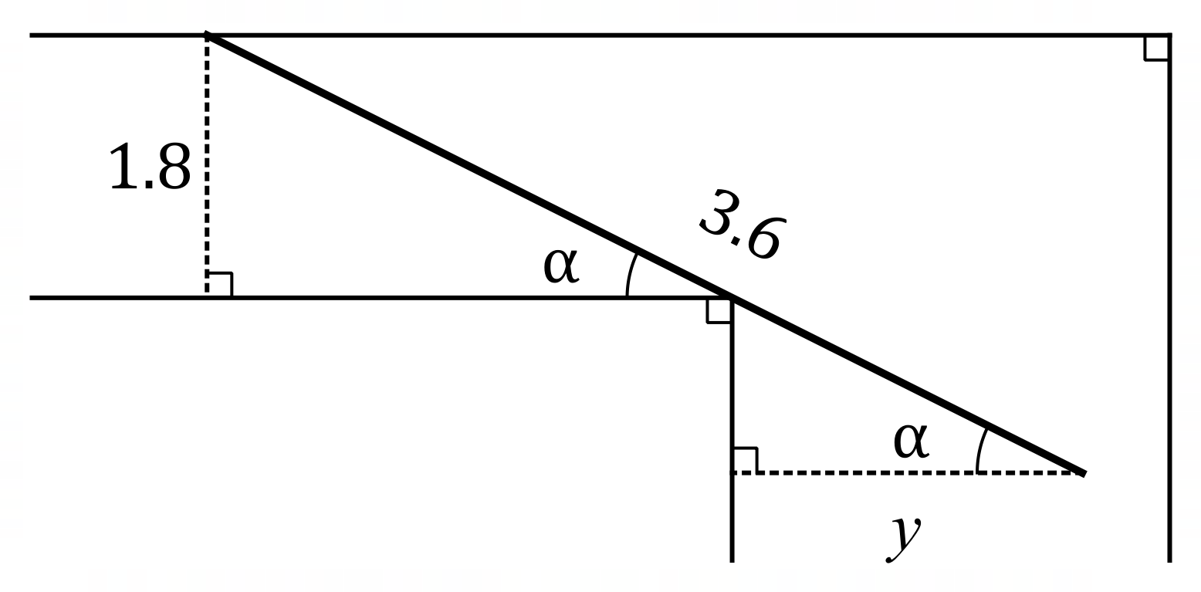
A corridor in a building is $1.8$ metres wide and meets
a second corridor at right angles. The diagram shows
a straight pipe, of length $3.6$ metres and negligible width,
being carried horizontally around, and just touching, the
corner. One end of the pipe touches the outer wall of
the first corridor and the other end protrudes $y$ metres
into the second corridor. The angle between the pipe
and the wall of the first corridor is $α$.

(a) Show that $y=3.6\cos{α}-1.8 \begin{matrix}\cos{α} \\ \overline{\sin{α}}\end{matrix}$ metres. (2 marks)
Solution
Let $x$ be length of wall from foot of perpendicular to corner in first corridor:

$$x\tan{α}=1.8⇒x=1.8\frac{\cos{α}}{\sin{α}}, x+y=3.6\cos{α}$$
Hence
$$y=3.6\cos{α}-1.8\frac{\cos{α}}{\sin{α}}$$

Specific behaviours
ü one correct relation, with any introduced variable(s) defined
ü clearly shows derivation of formula for $y$

(b) Use calculus to determine, with justification, the angle $α$ that maximises the distance $y$.
(4 marks)
Solution
First derivative of $y$ wrt $α$:
$$y^{'}\left(α\right)=-3.6\sin{α}-1.8\left(\frac{-\sin{α}\sin{α}-\cos{α}\cos{α}}{\sin^{2}{α}}\right) \\ =-3.6\sin{α}+\frac{1.8}{\sin^{2}{α}}$$
For stationary point:
$$-3.6\sin{α}+\frac{1.8}{\sin^{2}{α}}=0⇒\sin^{3}{α}=0.5⇒α=0.9169$$
Nature of stationary point:
$$y^{''}\left(0.9169\right)=-6.57$$

Since $y^{''}\left(0.9169\right)<0$ then the curve is concave down and as $y^{'}\left(0.9169\right)=0$ there is a local maximum when $α=0.9169$.

Specific behaviours
ü obtains $y'(α)$ in any form
ü solves $y^{'}\left(α\right)=0$ to obtain $α_{CRIT}$
ü obtains correct value for $y''(α_{CRIT})$
ü justifies $α_{CRIT}$ maximises $y$

(c) What is the minimum width of the second corridor for the pipe to pass around the corner?
Solution
$$y=3.6\cos{0.9169}-1.8\frac{\cos{0.9169}}{\sin{0.9169}}=0.81$$
The minimum width of the second corridor is $0.81$ metres.

Specific behaviours
ü correct minimum width (no need for units)

(1 mark)

